# Chapter 1: Introduction

## – Introduction to project

“Street Dog Care and Pet Shop Center” is an online services center where they care for the street dog and has a shop where any kind of accessories or food related to the pet is available. This shop cares the street dog for free.

“Street Dog Care and Pet Shop Center” is an online management system which help people to share the problem occur on the street dogs. The management system helps to increase marketing and buying & selling of goods related to the pets. The pets are well treated through the doctors and the professional trainers.

People can even buy pets like cats, dogs, rabbits, etc. from “Street Dog Care and Pet Shop Center” And also they can buy balanced diet based on age & breeds of pets. Interested people can donate fund for the care of street dog care in the application provide information.

## – Background of the project

As the increase of the malnourishment, disease, and illness on the dog in the society. The people were unable to treat the stray dogs and also they were unable to contact to the dog care center which treats animals in a free cost. So, to avoid such a problem I am going to develop an application which can help people to easily contact with dog care center which freely treat a dog with no cost.

By using this application people can also buy or adopt pets according to their choice. As the people are being love with the pets now, they can easily adopt or buy from here. And people can also donate some cash to the system provided information for the future use of social services for the street dog care.

## – Problem Statement

“Street Dog Care and Pet Shop Center” used to record the information of pets and the accessories on the record file by using this application the record can be record on the database. The customer data are also automatically record on the database. This project helps to reduce the cost and time consumption of both shop & care center and the customer.

As the attractive GUI provided by the project, the customer can easily use the system and order the pets and their accessories and they can easily contact to the care center for the help of the street dog.

However, by using this application the data of this care and shop center is securely record on the database and also the data cannot be lost or thief by the unauthorized people. when they used paper data recording there is a more chance to be data lose and theft. The project helps to get more profit for this care and shop center.

## – Description of the project

For this project, the user-friendly GUI is created which help user / customer to use the system easily and efficiently. The detail information of the user / customer, admin and the product will be register on the database. The role of the admin is to add the pet’s accessories and the details information about the pet on the system. Customer can easily buy the products from different places using a smartphones or a laptop. There will be management of data security of the customer and the products in a system.

### – Features of the project

The main features of this project are as follows:

* Login and Signup system for the customer and admin.
* People can know about the work done by their dog care team.
* Adopt dogs or buy a pets.
* Customer can get detail information about the pet and their accessories from different places.
* People can buy pet and pet accessories online.
* Increment of sell of accessories than physical store in cheap price.
* People can donate cash to a care center bank account.

## – Overview of the project

This project contains the user friendly GUI design which makes user to use easily and efficiently. The social works done by this organization will be added on the homepage of the website. Admin add the detail information of the pets and the pet’s accessories on the application. Customer can register their account for free and login for the buy of the pets and accessories. Customer can adopt a dog and can buy the pets according to their wants. Costumer can get suggestion with the doctors and the professional about the diet food and buy according to their suggestions. People from different places can get detail information of this care center and the shop easily through the internet. If they want to donate a cash to them then they can donate on the application provide bank information.

# Chapter 2: Scope of the project

## 2.1 – Scope

The scope of this project is to increase the productivity of the goods of the pets. As the increase of the pets there will be the increase of the productivity of the foods and other pet accessories. And also help to increase the PCI of the country and the skills of the doctors will also be increase. And also with the treatment of the street dog in free of cost people of the society will get knowledge that no more harm to the animals.

## 2.2 – Limitation

* Due to poor internet connection can lead people to unaccess to the site.
* Billing have to done through hand.
* People cannot get detail information about the products.
* People have to visit bank for the donation.
* People have to visit care center to take dogs after they adopt.
* Caring team may not be available during the people contact.

## 2.3 – Aims

The aims of this project are:

* New user can be register and login for the details information about the pets and their accessories.
* Provide user-friendly GUI which help customer to user easily and efficiently.
* Provide detail information related to the product.
* This project will provide facility for a people to be connect to their care team and help the team to care the stray dogs who are suffering from different types of diseases or natural defects for free.
* This project will help dog/puppy lovers to adopt them online from different places far or near.
* People can donate funds on the application provided bank information.

## 2.4 – Objectives

The objectives of the above aims are:

* Designing different type of modeling’s like flow diagram, use case, activity diagram, etc.
* Create user interactive GUI of the system.
* For security of the system, user verification system and password will be used.
* Testing will be done for not occur bugs during the system running.
* Documenting all designs, modeling’s and development information.

## 2.5 – Overview of the scope

This project can be used by other dog care and pet shop center too. There are many dog care center but they just care for the home dog so they this application is used for the care of the who dog who are not cared by any people. Any people can visit this website and contact to the care center for the help of the street dog and if they are the pet lover they can also buy the pets and the pets accessories.

# Chapter 3: Development Methodology

## 3.1 – Description of the design methodology chosen

The linear sequential life cycle model which flows from top to bottom phase by completing one phase upon another is known as waterfall model. I have chosen waterfall model because of the following reasons:

* It clearly defines the requirement and easy to understand in a small project.
* It clearly defined the stages of the SDLC.
* At a time a single phase is processed and completed.
* Helps to understood the milestone of the project. (Anon., 2019)

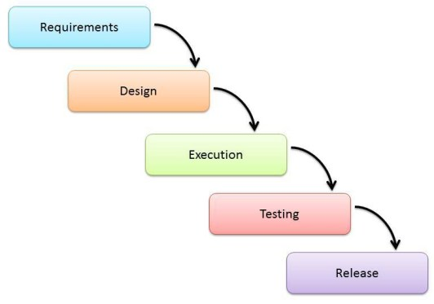

***Image: Waterfall model***

## 3.2 – Design Pattern

**Model View Controller [MVC] Pattern:**

MVC Pattern separates the design pattern into 3 different parts. They are explained below:

* **Model:**

It helps to manage the data which is retrieve and store by an application from the database.

* **View:**

It helps to display the data fetched by the model in a systematic format. The contains design of the system.

* **Controller:**

It helps to handle the Model and View layers to work together. (Anon., 2019)

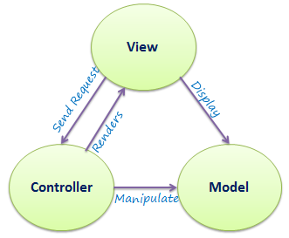

***Image: MVC Pattern***

## 3.3 – Architecture

**Client Server Architecture:**

It is the model where the client sends the requests and services to the server and then the server manages the services & request and send back to the clients. Servers are a powerful computer so many clients can connect to a single server.

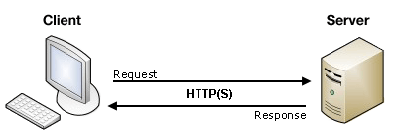

***Image: Client-Server Architecture***

# Chapter 4: Project Planning

My plan is to complete the full project in a time period so I have breakdown into different phases.

## 4.1 – WBS [Work Breakdown Structure]

Work Breakdown Structure is a process of breaking a project which makes task to be easily manageable parts. WBS visually defines the scope of the project in a chunk so which the project team can easily understand. It explains and organize the work of the project. It also helps to identify the potential risk of the project and identify the cost of the project.

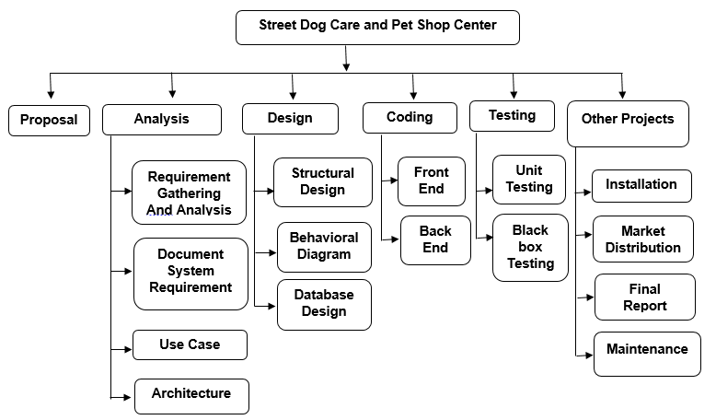

***Image: Work Breakdown Structure***

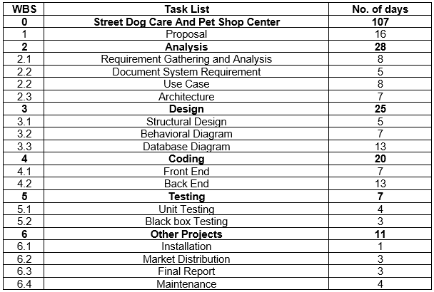

***Image: WBS with time table.***

## 4.2 – Milestones

The major milestones are:

|  |  |
| --- | --- |
| **Milestones** | **Delivery Dates** |
| Proposal of the project | 9th April, 2019 |
| Requirement Analysis Specification | 7th May, 2019 |
| Design Specification | 1st June, 2019 |
| Coding | 21st June, 2019 |
| Testing | 28th June, 2019 |
| Other Projects | 9th July, 2019 |

***Image: Milestones***

## 

## 4.3 – Gantt chart

* Schedule of the project:

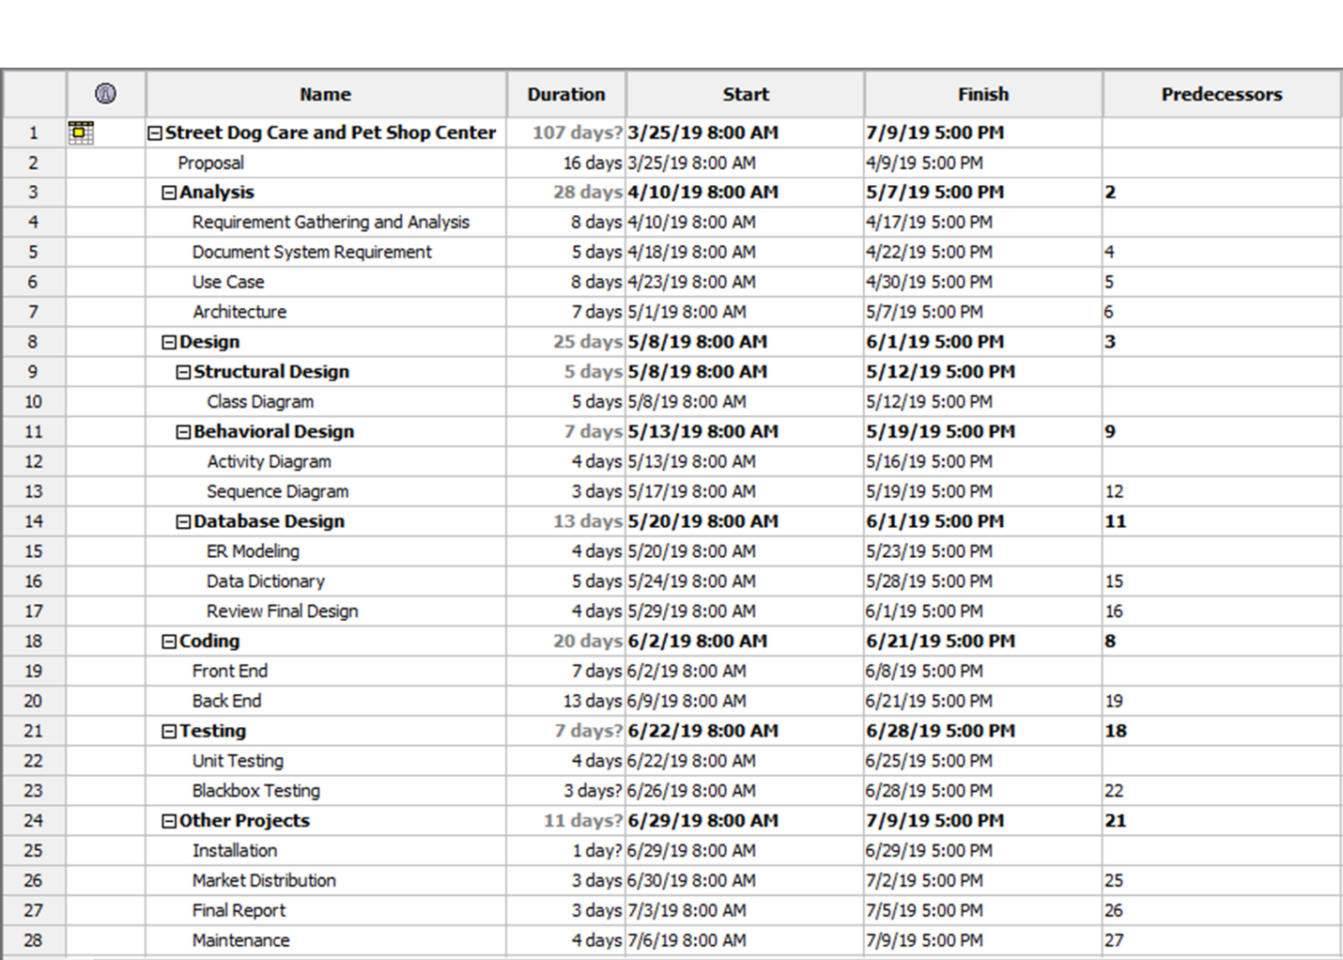

***Image: Street Dog Care and Pet Shop Center.***

* Grantt Chart of the Project:

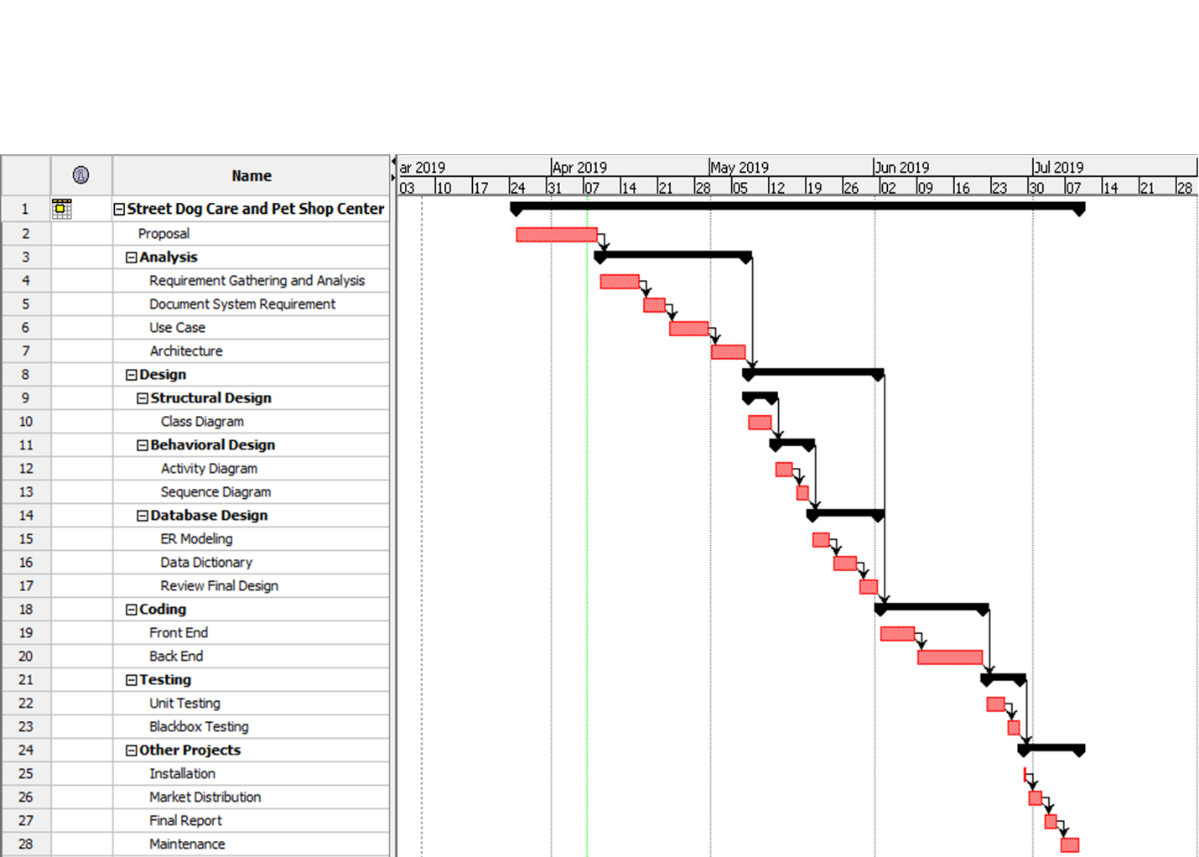

Image: Grants Chart of “Street Dog Care and Pet Care Center”

# Chapter 5: Risk Management

Risk management is the process of representing the risk which can be occur on the system. It helps to determine the projects weakness, power, threats and the opportunity of the project. It keeps us to be aware from the potential risk and the unexpected situation. As the good result outcome from the risk management table then our project is ready for the good result.

|  |  |
| --- | --- |
| **Value** | **Likelihood** |
| 1 | Low |
| 2 | Medium |
| 3 | High |

**Figure: Risk Likelihood**

|  |  |
| --- | --- |
| **Consequences** | **Value** |
| Very Low | 1 |
| Low | 2 |
| Medium | 3 |
| High | 4 |
| Very High | 5 |

**Figure: Risk Consequences**

|  |  |  |  |  |  |
| --- | --- | --- | --- | --- | --- |
| **S.N** | **Risk** | **Likelihood** | **Consequences** | **Impact** | **Action** |
| **1** | DDOS Attack | 2 | 4 | 8 | Firewall should be install for block the unnecessary packet. |
| **2** | Server Failure | 1 | 5 | 5 | Data should be backup time to time or automatic. |
| **3** | Data breach | 1 | 5 | 5 | Data must be backup and have to secure with the encryption process and security. |
| **4** | Hardware Failure | 2 | 4 | 8 | Hardware should have to check time to time and put in a secure place. |
| **5** | Technical Risk | 2 | 3 | 6 | Advanced technology should be use. |
| **6** | Unauthorized Access | 2 | 4 | 8 | Data should be encrypted so no one can read the data. |

# Chapter 6: Configuration Management

The tools which helps organization to manage, organize and control the changes in the documents, codes, and other entities in a systematic way during the Software Development Life Cycle is known as Configuration Management. It aims to control cost and work effort involved in making changes to the software system. (Guru99, 2019)

Features of Configuration Management are:

* Helps to track any changes occurs on the system.
* Easy to review the workflow of the project.
* Helps to control changes to configuration items.
* Helps to record the progress.

After the decision of the time and the cost we begin to work on the project. In a single directory the task is divided into a chunk. It helps to prove that there is no repetition of the task which they have to do or done.

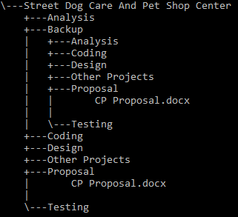

# Chapter 7: Conclusion

“Street Dog Care and Pet Shop Center” helps to treat a stray dog who are injured, ill for free. I use html, CSS, JavaScript, MySQL, etc for this project. This is small so I will use waterfall model for the design methodology.

Customer can create the account and login into the system. And then who are interested on the pet can buy the different types of pet and also dog lover can adopt the dog. And also the accessories related to the pets can also buy from the system on online. By providing all this features to the customer I will complete the project efficiently and successfully.

# Chapter 8: References

Anon., 2019. *Php-html.net.* [Online]   
Available at: http://php-html.net/tutorials/model-view-controller-in-php/  
[Accessed 6 April 2019].

Anon., 2019. *www.tutorialspoint.com.* [Online]   
Available at: https://www.tutorialspoint.com/sdlc/sdlc_waterfall_model.htm  
[Accessed 6 April 2019].

Guru99, 2019. *Guru99.com.* [Online]   
Available at: https://www.guru99.com/software-configuration-management-tutorial.html  
[Accessed 07 April 2019].